LAB 2

8 PUZZLE PROBLEM

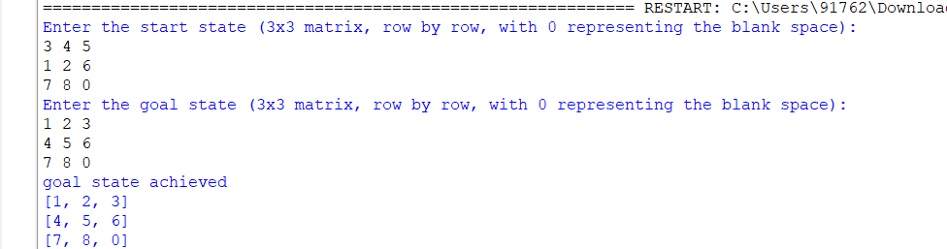

ITERATIVE DEEPENING SEARCH

